Chinese Sesame Noodles with Veggies!
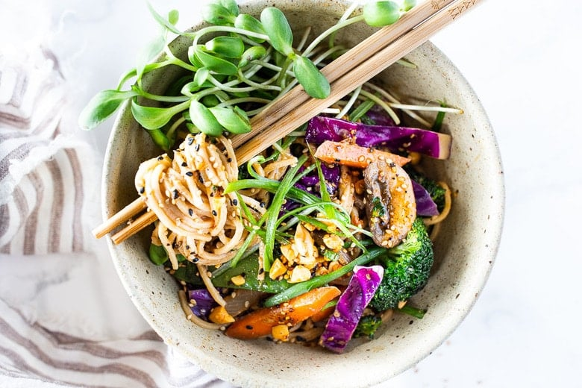
DESCRIPTION:
Flavorful Sesame Noodles, loaded up with healthy veggies and tossed in the most delicious, creamy, vegan Sesame Sauce! Make this in 20 minutes flat! Keep it vegan or add chicken- up to you!
INGREDIENTS:
1–2 tablespoons oil
4 cloves garlic, rough chopped
1 tablespoon ginger, chopped
1/2 an onion, sliced
4 cups sauté -able veggies (cabbage, peppers, broccoli, mushrooms, asparagus, snow peas, etc.) cut small.
4–5 ounces dry noodles (soba noodles, buckwheat noodles, chow mein noodles, low mein, spaghetti, brown rice noodles , gluten-free noodles, etc.)
3 tablespoons soy sauce (Or GF Braggs Liquid Aminos)
3 tablespoons tahini pasta, or Chinese Sesame Paste
1–2 tablespoons water
2 tablespoons rice wine vinegar
2 tablespoons sesame oil
1 tablespoon honey or vegan alternative like maple
1–2 teaspoon chili paste or sriacha, more to taste
Salt and pepper to taste

INSTRUCTIONS:
Boil water for pasta.
In a large skillet (or wok) heat oil over medium heat. Add onion, garlic and ginger and the veggies of your choice. Saute, 3-4 minutes, turn heat down to low, and continue cooking until just tender.
At the same time, cook the noodles according to directions and make the Creamy Sesame Sauce.
Creamy Sesame Sauce: Place all ingredients in a small bowl and whisk with fork until smooth Taste Add more chili paste and salt and pepper to taste.
Once the veggies are tender, and noodles are drained toss them together along with the sauce, coating well. Serve warm, top with sprout or other options.
Enjoy!
NUTRITION:
Serving Size:
Calories: 497
Sugar: 10.8 g
Sodium: 960.8 mg
Fat: 22.6 g
Saturated Fat: 3.2 g
Carbohydrates: 66.4 g
Fiber: 4.2 g
Protein: 15.5 g
Cholesterol: 0 mg

